ARTIFICIAL INTELLIGENCE ASSIGNMENT 1

TASK 1:
Client-Server Architecture in Web Applications
Introduction
Client-server architecture is a computing model in which two main components, the client and the server, communicate with each other to provide services to users. In web applications, the client is usually a web browser, while the server processes requests and sends responses.
1. Role of the Client (Browser)
The client is the user's device or web browser, such as Google Chrome, Mozilla Firefox, or Microsoft Edge. Its main responsibilities are:
- Displaying the website's interface using HTML and CSS.
- Running JavaScript to provide interactive features.
- Collecting user input through forms, buttons, and other controls.
- Sending HTTP or HTTPS requests to the server.
- Displaying the data received from the server.
2. Role of the Server
The server is a computer or software application that receives and processes requests from clients. Its responsibilities include:
- Receiving and handling client requests.
- Executing application logic and business rules.
- Communicating with a database when necessary.
- Authenticating users and checking permissions.
- Sending responses, such as HTML pages, JSON data, or error messages.

3. How Data Flows Between Client and Server
The communication process typically follows these steps:
- The user opens a website in a browser.
- The browser sends an HTTP or HTTPS request to the server.
- The server processes the request and may retrieve information from a database.
- The server sends an HTTP response containing the requested information.
- The browser processes the response and displays the result to the user.
This process is known as the request-response cycle.
4. Real-World Example
An online shopping website such as Amazon uses client-server architecture.
When a customer searches for a product, the browser sends a request to the server. The server searches for matching products, retrieves relevant information, and sends the results to the browser. The browser then displays the products to the customer.
When the customer adds an item to the cart, another request may be sent to the server to update the cart. During checkout, the server also handles important operations such as order processing and payment verification.
Conclusion
Client-server architecture separates the user interface from server-side processing. It makes web applications easier to maintain, manage, and scale. It is widely used in online shopping, banking, social media, educational platforms, and many other web applications.

TASK 2:

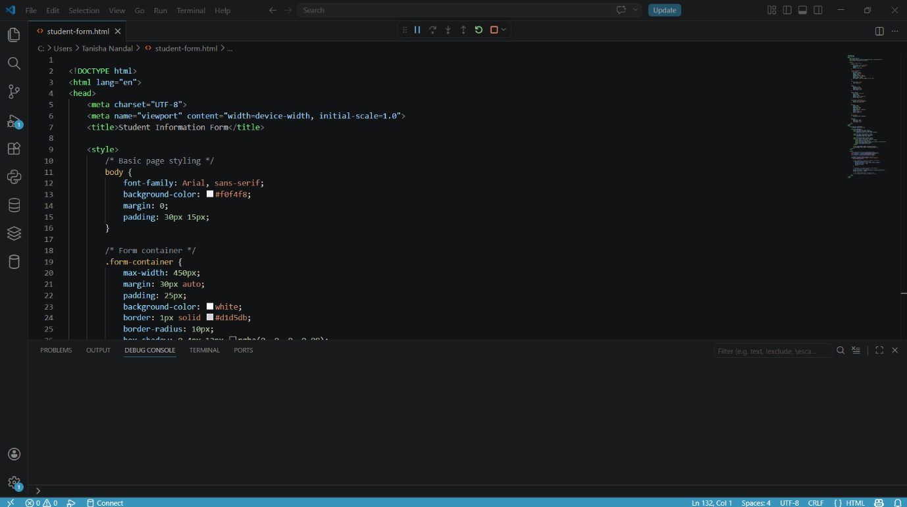
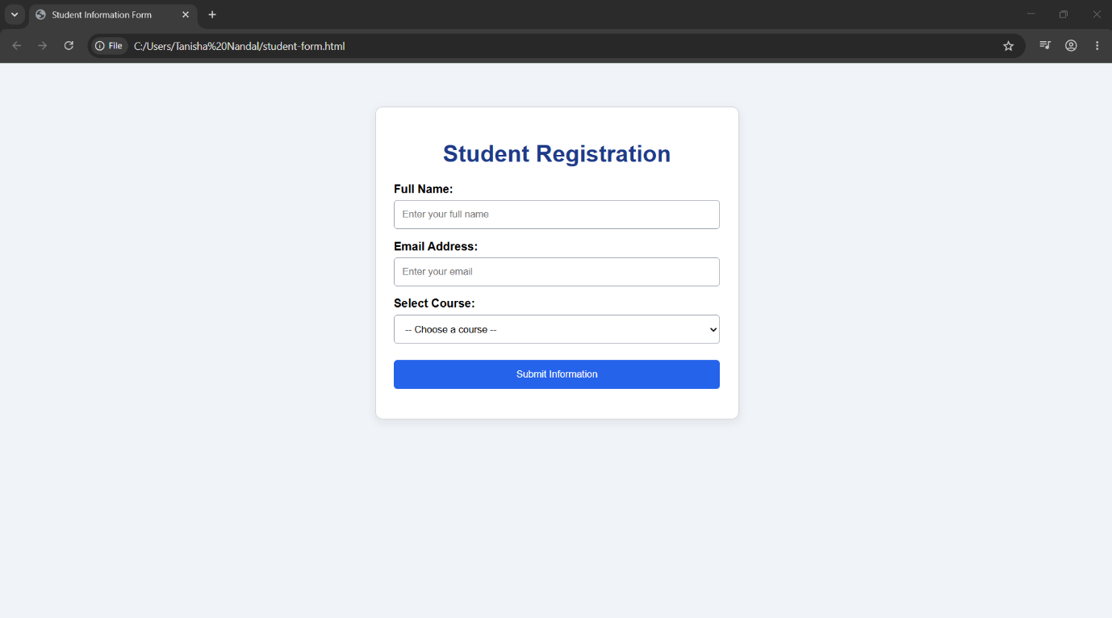

SOURCE CODE:

<!DOCTYPE html>
<html lang="en">
<head>
<meta charset="UTF-8">
<meta name="viewport" content="width=device-width, initial-scale=1.0">
<title>Student Information Form</title>

<style>
/* Basic page styling */
body {
font-family: Arial, sans-serif;
background-color: #f0f4f8;
margin: 0;
padding: 30px 15px;
}

/* Form container */
.form-container {
max-width: 450px;
margin: 30px auto;
padding: 25px;
background-color: white;
border: 1px solid #d1d5db;
border-radius: 10px;
box-shadow: 0 4px 12px rgba(0, 0, 0, 0.08);
}

h1 {
text-align: center;
color: #1e3a8a;
}

label {
display: block;
margin-top: 15px;
margin-bottom: 6px;
font-weight: bold;
}

input, select {
box-sizing: border-box;
width: 100%;
padding: 11px;
border: 1px solid #9ca3af;
border-radius: 5px;
}

input:focus, select:focus {
outline: 2px solid #93c5fd;
border-color: #2563eb;
}

button {
width: 100%;
padding: 12px;
margin-top: 22px;
color: white;
background-color: #2563eb;
border: none;
border-radius: 5px;
cursor: pointer;
}

button:hover {
background-color: #1d4ed8;
}

#message {
margin-top: 15px;
text-align: center;
font-weight: bold;
}
</style>
</head>
<body>
<main class="form-container">
<h1>Student Registration</h1>

<form id="studentForm">
<label for="name">Full Name:</label>
<input type="text" id="name" name="name"
placeholder="Enter your full name" required>

<label for="email">Email Address:</label>
<input type="email" id="email" name="email"
placeholder="Enter your email">

<label for="course">Select Course:</label>
<select id="course" name="course" required>
<option value="">-- Choose a course --</option>
<option value="BCA">BCA</option>
<option value="BSc Computer Science">BSc Computer Science</option>
<option value="BTech">BTech</option>
<option value="MCA">MCA</option>
</select>

<button type="submit">Submit Information</button>
<p id="message" role="status" aria-live="polite"></p>
</form>
</main>

<script>
// Get references to the form and message element.
const studentForm = document.getElementById("studentForm");
const emailInput = document.getElementById("email");
const message = document.getElementById("message");

// Validate the email before processing the form.
studentForm.addEventListener("submit", function (event) {
event.preventDefault();

// Stop submission if the email is empty or only spaces.
if (emailInput.value.trim() === "") {
message.textContent = "Error: Email cannot be empty.";
message.style.color = "red";
emailInput.focus();
return;
}

// The browser also checks the email format because
// the input type is set to email.
message.textContent = "Student information validated successfully!";
message.style.color = "green";

// This example demonstrates validation only.
// No information is saved to a database or server.
});
</script>
</body>
</html>

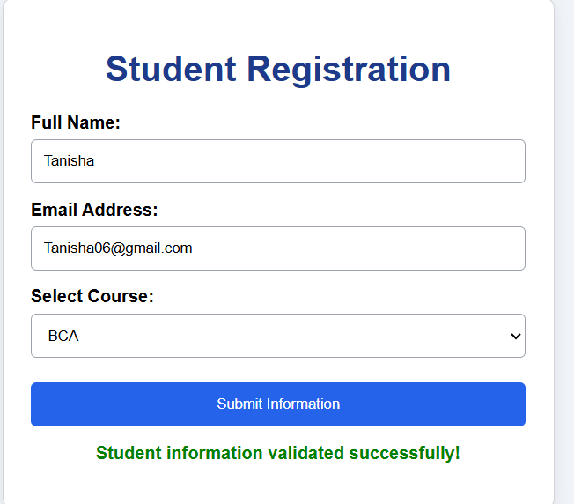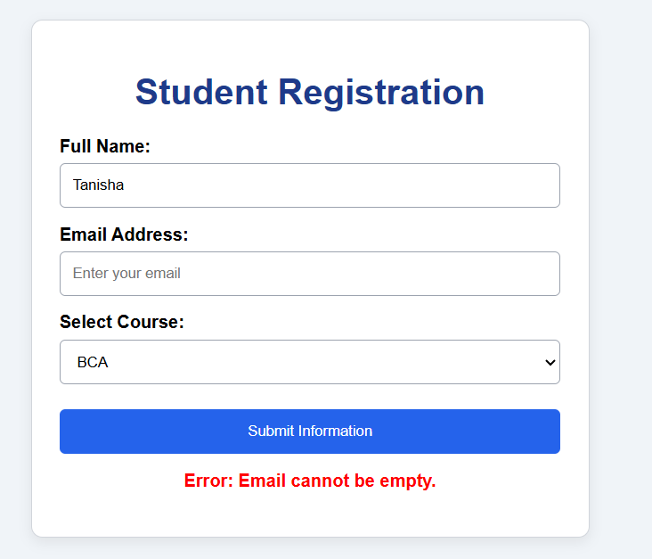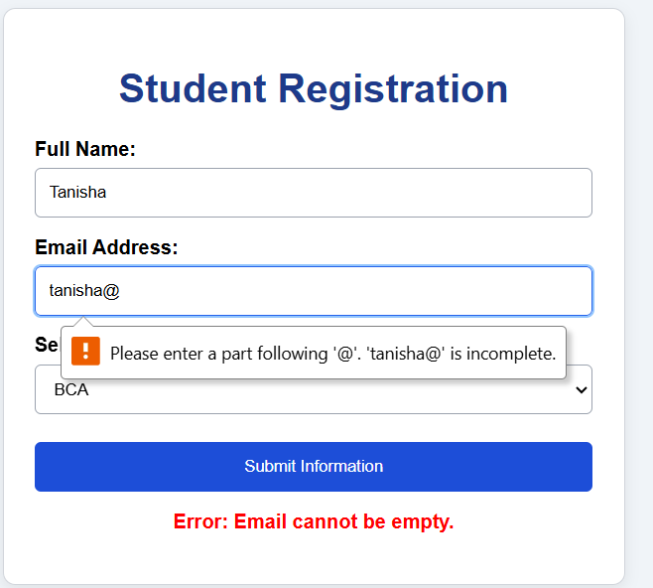

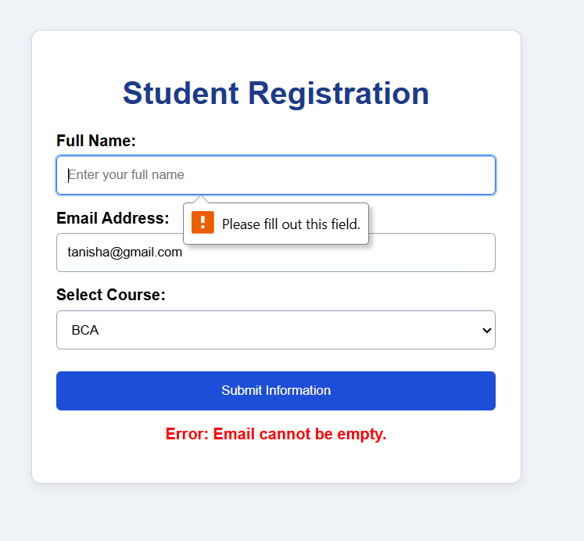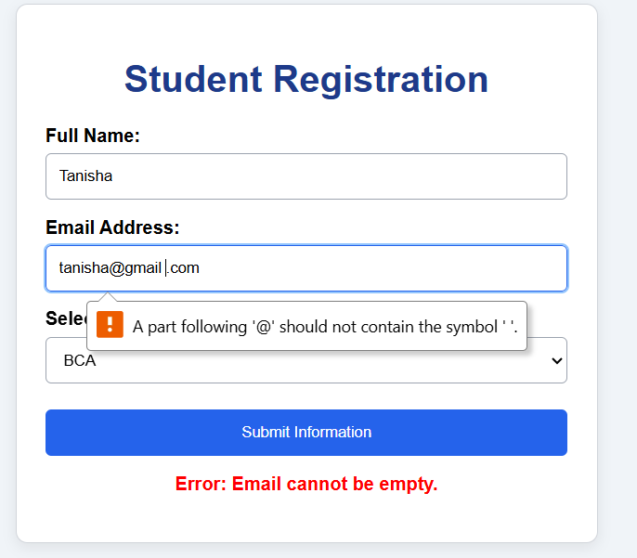

TASK 3:
SOURCE CODE:

<!DOCTYPE html>
<html lang="en">
<head>
<meta charset="UTF-8">
<meta name="viewport" content="width=device-width, initial-scale=1.0">
<title>My Portfolio</title>

<style>
body {
font-family: Arial, sans-serif;
margin: 0;
background: #f4f4ff;
color: #333;
}

header {
background: #333366;
color: white;
padding: 15px;
text-align: center;
}

nav a {
color: white;
margin: 10px;
text-decoration: none;
}

section {
padding: 30px;
text-align: center;
}

img {
width: 130px;
height: 130px;
border-radius: 50%;
}

.card {
background: white;
margin: 10px auto;
padding: 15px;
max-width: 500px;
border: 1px solid #ccc;
border-radius: 8px;
}

input, textarea {
width: 90%;
padding: 10px;
margin: 8px;
border: 1px solid #aaa;
border-radius: 5px;
}

button {
background: #333366;
color: white;
padding: 10px 20px;
border: none;
cursor: pointer;
}

footer {
background: #333366;
color: white;
text-align: center;
padding: 15px;
}

@media (max-width: 600px) {
nav a {
display: inline-block;
margin: 5px;
}

section {
padding: 20px 10px;
}
}
</style>
</head>

<body>

<header>
<h1>My Portfolio</h1>
<nav>
<a href="#home">Home</a>
<a href="#about">About</a>
<a href="#skills">Skills</a>
<a href="#projects">Projects</a>
<a href="#contact">Contact</a>
</nav>
</header>

<section id="home">
<img src="https://placehold.co/150x150?text=My+Photo"
alt="My profile photo">
<h2>Hello, I'm Tanisha Nandal</h2>
<p>Aspiring Web Developer</p>
<a href="https://github.com/">GitHub</a> |
<a href="https://linkedin.com/">LinkedIn</a>
</section>

<section id="about">
<h2>About Me</h2>
<p>I am a student learning web development.
I enjoy creating websites using HTML, CSS and JavaScript.</p>
</section>

<section id="skills">
<h2>My Skills</h2>
<div class="card">HTML</div>
<div class="card">CSS</div>
<div class="card">JavaScript</div>
</section>

<section id="projects">
<h2>My Projects</h2>
<div class="card">
<h3>Student Registration Form</h3>
<p>A form created using HTML, CSS and JavaScript.</p>
</div>
<div class="card">
<h3>Personal Portfolio</h3>
<p>A responsive website about me and my skills.</p>
</div>
</section>

<section id="contact">
<h2>Contact Me</h2>

<form id="contactForm">
<input type="text" id="name" placeholder="Your Name">
<input type="email" id="email" placeholder="Your Email">
<textarea id="message" placeholder="Your Message"></textarea>
<button type="submit">Submit</button>
</form>

<p id="result"></p>
</section>

<footer>
<p>&copy; 2026 Tanisha Nandal</p>
</footer>

<script>
// Validate the contact form.
document.getElementById("contactForm").onsubmit = function(event) {
event.preventDefault();

let name = document.getElementById("name").value.trim();
let email = document.getElementById("email").value.trim();
let message = document.getElementById("message").value.trim();
let result = document.getElementById("result");

if (name === "" || email === "" || message === "") {
result.innerHTML = "Please fill in all fields.";
result.style.color = "red";
} else {
result.innerHTML = "Form submitted successfully!";
result.style.color = "green";
}
};
</script>

</body>
</html>

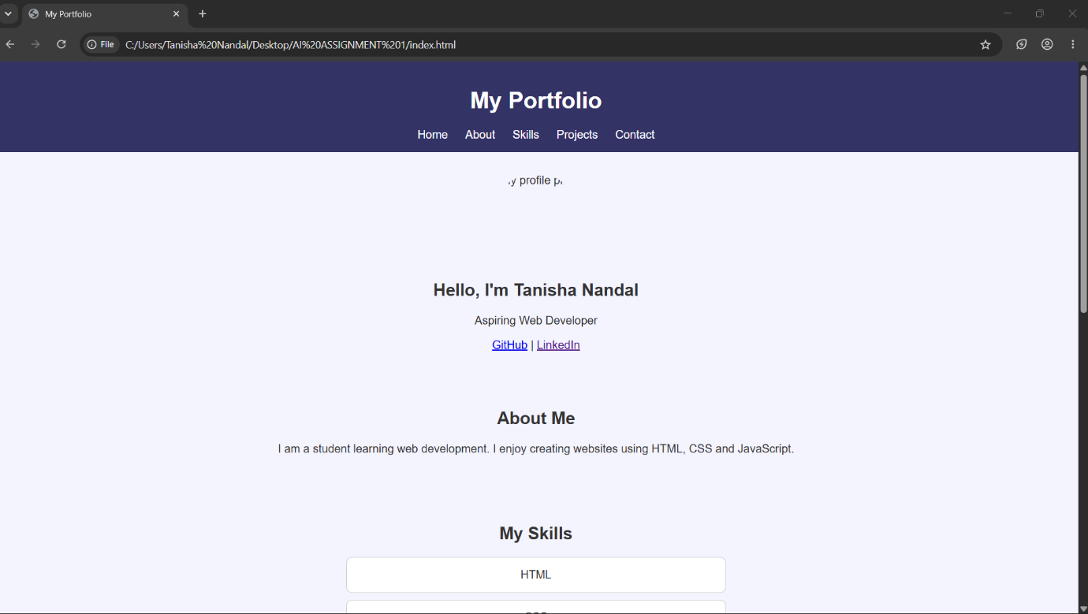
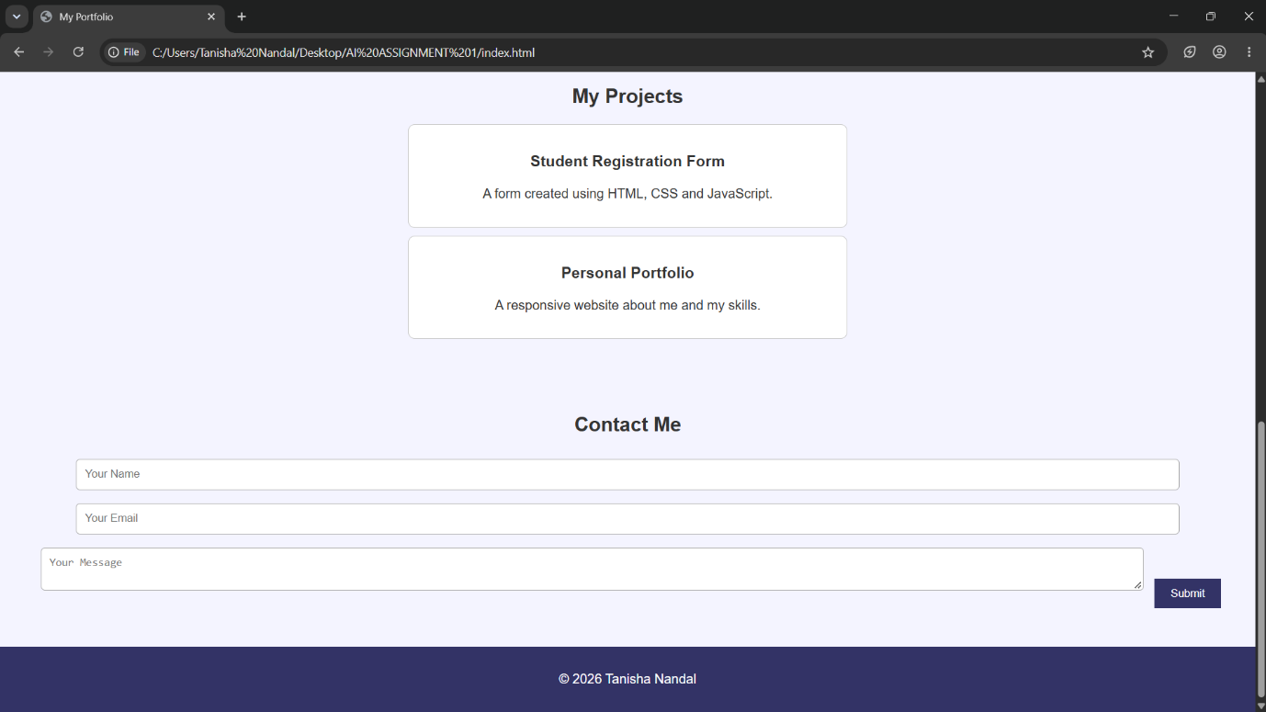

Implementation Report: Student Form and Personal Portfolio Website

1. Introduction
The objective of this assignment is to understand client-server architecture and develop two web pages using HTML5, CSS3, and JavaScript. The first project is a student information form, and the second is a responsive personal portfolio website.
2. Technologies Used
- HTML5: Provides the structure of the web pages and forms.
- CSS3: Controls colors, spacing, borders, typography, layouts, and responsive design.
- JavaScript: Implements client-side validation, mobile navigation, and dynamic content.
- Web browser: Used to run and test the projects.
3. Implementation of Task 1
Client-server architecture was explained using the browser as the client and a web server as the request processor. The request-response cycle and an online shopping example were used to demonstrate how clients and servers exchange information.
4. Implementation of Task 2
A student registration form was created with fields for full name, email address, and course selection. CSS was used to provide padding, borders, spacing, and a clean layout.
JavaScript handles the form submission event. The program checks whether the email field is empty after removing leading and trailing spaces. If the field is empty, an error message is displayed and processing stops. Otherwise, the form displays a success message. The browser's built-in email validation checks the email format.
5. Implementation of Task 3
A responsive personal portfolio was developed with Home, About, Skills, Projects, and Contact sections.
CSS Grid was used for the main content layouts. Media queries adjust the layout for smaller screens. JavaScript controls the mobile navigation menu, updates the footer year, and validates the contact form before showing a result.
The website uses a consistent color scheme, cards, buttons, spacing, and section headings to improve readability.
6. Algorithm
Student Form Algorithm
- Display the student information form.
- Accept the student's name, email, and course.
- Intercept the form submission.
- Remove leading and trailing spaces from the email.
- If the email is empty, display an error and stop.
- Otherwise, display a validation success message.
Portfolio Contact Form Algorithm
- Display the contact form.
- Read the name, email, subject, and message.
- Prevent the default form submission.
- Check whether any required field is empty.
- If any field is empty, display an error.
- Otherwise, check the email format.
- If the email is invalid, display an error.
- If all checks pass, display a success message.
7. Testing
The projects were tested with valid input, missing fields, empty email values, invalid email formats, and mobile navigation.
The expected results were compared with the observed browser behavior. Actual test results and screenshots should be added after running the programs.
8. Challenges and Solutions
Potential challenges included making the page responsive, validating form fields, and managing navigation on small screens.
CSS media queries were used to adjust the layouts. JavaScript event listeners were used for form validation and menu interaction. Clear error messages help users correct their input.
9. Limitations
Both forms demonstrate client-side behavior only. They do not save student records to a database or send contact messages to an email address. A server-side application and suitable storage or email service would be needed to implement those features.
10. Conclusion
This assignment demonstrates the fundamentals of web development using HTML, CSS, and JavaScript. It provides practical experience with forms, validation, responsive layouts, navigation, and the client-server request-response model.

